Project 2
Topic: Smart Double-Network GelMA + HA Scaffold with Embedded PVDF Sensor for Cartilage Regeneration
- Introduction:
Cartilage injuries pose significant challenges due to the tissue's limited self-healing capacity. Current treatments primarily focus on structural and bioactive support but lack mechanisms for real-time monitoring, leaving clinicians without crucial information about mechanical stress or recovery progress. To address these gaps, this project introduces a smart scaffold combining GelMA and HA in a double-network structure. The integration of a PVDF pressure sensor provides dynamic stress monitoring, while the BLE module enables wireless data transmission. This innovative design bridges regenerative and diagnostic functionalities, setting a new standard for cartilage repair.

- Background and motivation:
Cartilage damage caused by degenerative diseases or traumatic injuries is challenging to repair due to the limited self-healing capacity of cartilage tissue. Current cartilage regeneration scaffolds primarily provide structural support and bioactive environments but lack real-time monitoring capabilities, making it difficult to track mechanical stress and regeneration progress after surgery. To address these limitations, this project proposes a novel double-network GelMA hydrogel scaffold with an embedded Polyvinylidene Fluoride (PVDF) pressure sensor. [1] This design integrates real-time pressure monitoring with a scaffold structure that promotes cartilage regeneration, providing dynamic data support for personalized treatment. At the same time, it can also detect whether there are abnormalities in the patient's knee usage habits and provide doctors and therapists with diagnostic credentials to design appropriate treatment plans for the patient.

- Commonly used materials in previous studies
- Hyaluronic acid (HA)
- Naturally present in cartilage extracellular matrix and excellent biocompatibility.
- Promotes chondrocyte proliferation and mimics the lubrication function of cartilage.
- Weak mechanical properties and insufficient for load-bearing applications. [2]
(2) Alginate:
- Good biocompatibility and non-toxic degradation products.
- Easily processed and can form scaffolds with good porosity.
- Low mechanical strength and lacks cell adhesion sites.
- Often needs to be combined with other materials. [3]
(3) Polyethylene glycol (PEG)
- Good mechanical properties and adjustable pore structure.
- Biocompatibility can be improved through modification
- Lacks cell adhesion sites and requires bioactive modifications.
- Degradation products may lower local pH, affecting cell viability. [4]
(4) Polycaprolactone (PCL)
- High mechanical strength and suitable for load-bearing scaffold designs.
- Slow degradation rate and maintains long-term structural stability.
- Degradation products may cause inflammatory reactions.
- Lacks cell adhesion sites and needs combination with natural materials. [5]
(5) Poly (lactic-co-glycolic acid) (PLGA)
- Good mechanical properties and adjustable degradation rate.
- Commonly combined with alginate or collagen in composite scaffolds.
- Degradation may lead to local acidic accumulation. [6]
(6) Gelatin Methacrylate (GelMA)
- Similar structure to natural extracellular matrix and promotes cell adhesion and proliferation.
- Mechanical properties can be precisely adjusted through photocrosslinking; suitable for 3D printing personalized scaffolds.
- Non-toxic degradation products; compatible with various biomaterials.
- Relatively weak mechanical strength; requires combination with reinforcing materials. [7]

- Current technical limitations and challenges:
(1) Interface compatibility issues:
- PVDF is hydrophobic, while the GelMA matrix is ​a hydrophilic material and requires surface modification.
(2) Mechanical stability of double network hydrogel:
- The dual network needs to balance flexibility and strength and needs to provide effective pressure conduction.
(3) Stability of piezoelectric properties inside hydrogel:
- The long-term performance of PVDF in high humidity environments needs to be tested.
(4) Biocompatibility matches degradation rate:
- PVDF is a non-degradable material, and a protective layer may need to be added to avoid toxicity in the body.

- Aim of this design:
To design a regenerative GelMA scaffold that repairs damaged cartilage and dynamically monitors mechanical stress and recovery progress by integrating a PVDF pressure sensor and a BLE module for real-time data transmission.

- Innovation of the design:
(1) Smart monitoring integration:
- The embedded PVDF pressure sensor enables real-time monitoring of mechanical loading conditions, providing feedback for post-surgical recovery.
(2) Double-network design:
- Combines GelMA’s rigidity with HA’s flexibility to balance mechanical support and nutrient transport, mimicking the gradient structure of natural cartilage.
(3) Personalized manufacturing:
- Utilizes 3D printing to produce scaffolds tailored to the patient’s specific cartilage defect shape.

- Components of the device:
  - Materials:
- First layer: GelMA + HA + Nanoparticle base:
- GelMA (Gelatin Methacrylate): Provide structural support and mimic the extracellular matrix for cell adhesion.
- HA: Enhance flexibility and dissipates energy
- Nanoparticles: Functionalized nanoparticles (e.g., silica nanoparticles) to enhance the mechanical strength and porosity of the base layer.
- Photoinitiator: Use for UV-induced crosslinking of the GelMA hydrogel.
- Pressure Sensor: PVDF (Polyvinylidene Fluoride) piezoelectric sensor embedded within the base layer for mechanical stress monitoring. [8]
- PDMS: Embed PVDF to protect it from moisture body environment and improve durability and biocompatibility; furthermore, protect it from crosslinking process.
- Electrical energy storage: A microcapacitor to store energy generated by PVDF and provide a stable power supply to the BLE module.
- BLE (Bluetooth Low Energy) Module: A Bluetooth Low Energy module for real-time wireless transmission of data to a smartphone app.
- ADC (Analog-to-Digital Converter): Converts the analog signals generated by the PVDF sensor into digital signals for processing and transmission.
- Medical wire: To connect the electronic component.
- Hyaluronic Acid (HA): HA is highly hydrophilic, which can form a protect layer between

- Second layer:
- HA Flexible Network: A biocompatible polysaccharide that promotes extracellular matrix production and provides flexibility.
- Crosslinking Agents: EDC (1-Ethyl-3-[3-dimethylaminopropyl] carbodiimide) and NHS (N-Hydroxysuccinimide) used to chemically crosslink HA molecules.
- Buffer Solution: PBS (Phosphate-Buffered Saline), used as the solvent for HA and crosslinking agents.

  - Why choose these materials?
(1) GelMA (Gelatin Methacrylate):
- It mimics the natural extracellular matrix, promoting chondrocyte adhesion and proliferation.
- Its photocrosslinkable properties allow precise mechanical tunability, enabling the scaffold to match cartilage elasticity and strength.
- Offer superior biocompatibility and degradability.
(2) Nanoparticles:
- Functionalized silica nanoparticles improve mechanical strength and porosity, addressing GelMA’s inherent softness.
- Nanoparticles also enhance cell migration and nutrient transport within the scaffold.
(3) PVDF Sensor:
- Enables real-time monitoring of mechanical stress, a unique feature not offered by traditional scaffolds.
- Provides piezoelectric properties for energy generating, reducing reliance on external power sources.
(4) Microcapacitor:
- PVDF can generate electricity by transferring mechanical energy to electrical energy, providing its function and providing electricity for BLE to transfer data to the app. To store the electricity PVDF generate and provide BLE stable electricity supply, the electricity storage is essential in my design.
(5) BLE (Bluetooth low energy):
- Data transmission distance up to 100m. The transmission rate is up to 2Mbps, suitable for real-time data updates. Ensure low power consumption, ideal for long-term implant functionality.
(6) ADC (Analog-to-Digital Converter):
- An ADC is an electronic device that processes the analog signals generated by the PVDF sensor. When the PVDF piezoelectric sensor is subjected to pressure, it produces continuously varying analog voltage signals, which are converted into digital format by the ADC. This digital data can then be further read and processed by the BLE module.

6.3 Difficulties and challenges of device combining by using these materials:
(1) PDMS embedded with the electronic component to protect the equipment from the moisture environment and combine with the GelMA layer. However, GelMA is hydrophilic, but PDMS is hydrophobic; thus, the interface should not be well-interacted. Meanwhile, I design to use O₂ plasma treatment to change the surface property of the PDMS surface to contact with GelMA layer properly during the crosslinking process. However, PDMS will change to liquid phase faster after the plasma treatment, the GelMA combination should be processed immediately.

(2) PDMS is used to protect the electronic component, but the protection might also affect the accuracy of the pressure sensor (PVDF). To trade-off, the thickness of the PDMS should be taken into consideration during further experiment, in my design I do optimize the thickness. HA also has the same thickness and accuracy issues.

  - Material preparation:
- GelMA solution preparation:
- Dissolve GelMA (5%-10% w/v concentration) in PBS and add a photoinitiator (e.g., Irgacure 2959, 0.1%-0.5% w/v concentration).
- At this step, 1%-2% w/v HA is also mixed into the GelMA solution to allow HA to penetrate the GelMA matrix and partially form the dynamic network.
- Silica nanoparticles dispersion:
- Add PEG-modified silica nanoparticles (1%-5% w/v concentration) into the GelMA-HA solution to improve scaffold porosity and mechanical strength. Use ultrasonic agitation for 10 minutes to ensure uniform dispersion.
- PVDF pressure sensor preparation:
- Polarize the PVDF film (approximately 10 μm thick) to activate its piezoelectric properties.
- Encapsulate the PVDF film with PDMS to form a protective layer, preventing environmental and biological degradation during the crosslinking process.
- Further process the PDMS-encapsulated PVDF using oxygen plasma treatment to modify the surface, enhancing hydrophilicity and compatibility with the GelMA layer. [9]
- Surface treatment and coating:
- Perform Oxygen Plasma Treatment on the PDMS-encapsulated PVDF to introduce hydrophilic functional groups on the surface.
- Apply a thin HA coating on the plasma-treated PDMS surface to improve compatibility with the GelMA hydrogel. Ensure uniform coating to facilitate integration.
- HA solution preparation (for the second layer):
- Dissolve HA in PBS (1%-3% w/v concentration) and add crosslinking agents such as EDC/NHS (molar ratio 4:1) to stabilize the HA network during chemical crosslinking.

6.4 First layer: GelMA + Nanoparticle base [10]
(1) 3D printing the base layer:
- Load the prepared GelMA + nanoparticle solution into a digital light processing (DLP) 3D printer. Fabricate the base layer with the desired structure, ensuring consistent pore size and scaffold thickness.
(2) Embedding the Pressure Sensor:
- Carefully position the PDMS-encapsulated PVDF pressure sensor within the GelMA base layer during the printing process. Ensure the sensor is securely embedded without obstructing its functional area.
(3) UV Crosslinking:
- Expose the base layer to UV light (365 nm) for 2-5 minutes to initiate photocrosslinking of the GelMA hydrogel and secure the embedded PVDF sensor in place.

  - Second layer: HA flexible network
- Immersion and coating:
- Immerse the crosslinked GelMA base layer into the HA solution, ensuring HA penetrates the pores and uniformly coats the scaffold.
- Chemical crosslinking:
- Allow the HA to chemically crosslink using EDC/NHS over 4-6 hours at room temperature, forming a stable dynamic network.

6.7 Finalization
(1) Final Crosslinking:
- After HA crosslinking, perform an additional UV crosslinking step (e.g., 1-2 minutes) to ensure the GelMA and HA layers are cohesively bonded into a single, stable structure. This step strengthens the interfacial integration between layers.
(2) Scaffold Cleaning:
- Wash the scaffold thoroughly with PBS to remove residual crosslinking agents and any unreacted materials. This ensures biocompatibility for subsequent biological testing.

- Schematic diagram of the design
- Diagram of the fabrication process (draw by using biorender):
In the diagram the orange part is the electronic components and then do plasma treatment for surface modification and embed it in PDMS for protection, and the thickness of it will be around 50 micrometers. It achieves the isolation function without affecting the accuracy of the PVDF sensor.
And then do HA coating. During 3D printing, the PDMS-encapsulated PVDF sensor is embedded within the GelMA base. UV crosslinking solidifies the structure, ensuring proper integration. Then it will be immersed in HA solution and do Chemical crosslinking to form a stable network.
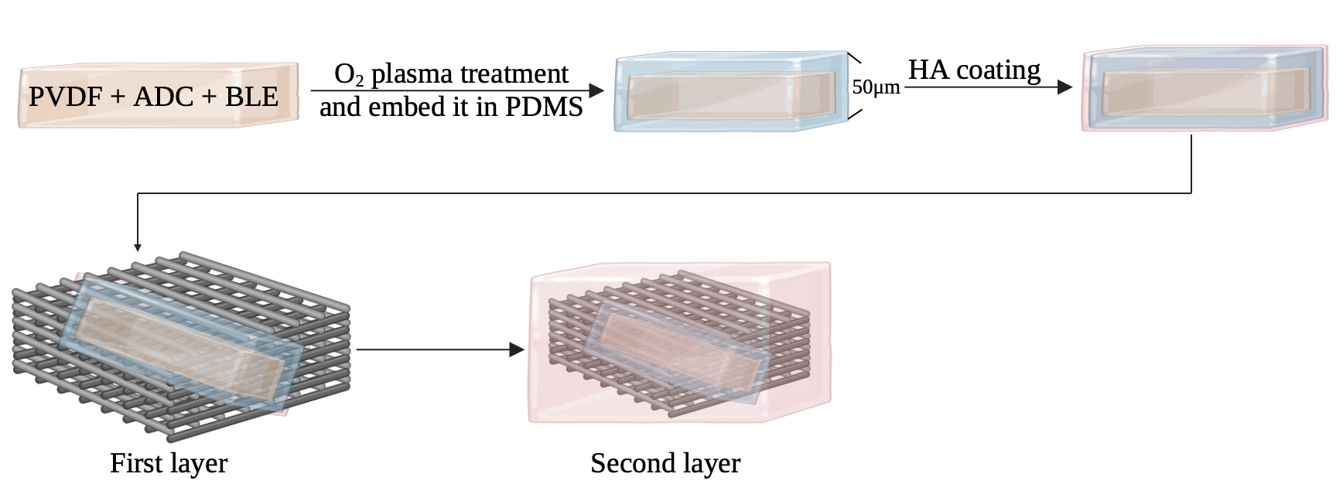
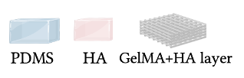
- Diagram of the implantation:
The illustration shows the device implanted in a knee joint, positioned within the defect area of the cartilage, during surgery. This placement ensures direct interaction with surrounding tissues to promote cartilage regeneration. The scaffold experiences vertical forces during weight-bearing activities such as walking, running, and jumping. These dynamic mechanical stresses are monitored in real-time by the PVDF pressure sensor embedded in the scaffold

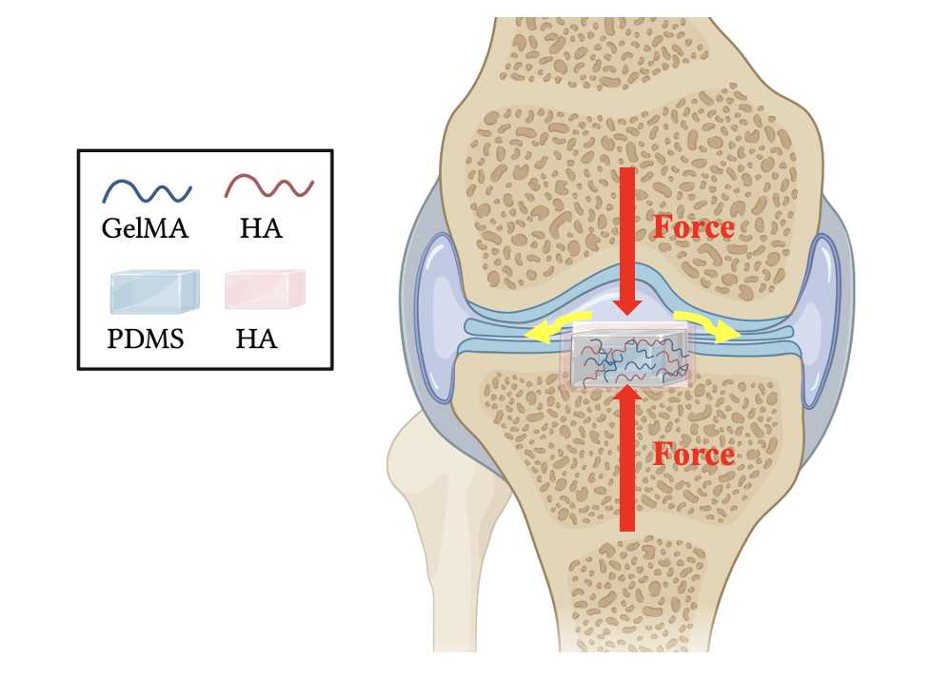

- Function of the device:
- Cartilage regeneration: Use a double-network GelMA hydrogel scaffold to support cell adhesion and proliferation, and in turn improve cartilage regeneration.
- Mechanical Stability: Provide structural support under physiological loading conditions for cartilage.
- Pressure Monitoring: Tracks mechanical stress across the scaffold to optimize recovery plans.
- Data Transmission: Sends real-time data to the app via BLE for continuous monitoring.

- Advantages:
- Double-network structure: GelMA provides stable static support, while HA enhances flexibility and dissipates energy through dynamic crosslinking.
- Functional integration: PVDF sensors embedded within the static network enable pressure monitoring, while the HA outer layer promotes biological activity and supports cartilage regeneration.
- Structural stability: PDMS protects electronic components, and oxygen plasma treatment combined with the HA coating resolves the interface bonding issues between layers.

- Health and failure risks:
- Biocompatibility Concerns: Non-biodegradable components (PDMS, PVDF) may cause fibrosis or chronic inflammation if left in the body long-term. Surgical removal could lead to additional complications.
- Sensor Accuracy: PDMS encapsulation may reduce sensor sensitivity. Improper placement or material thickness could affect pressure readings.
- Signal Interference: BLE data transmission may encounter interruptions, leading to incomplete monitoring.
- Infection Risk: As an implantable device, strict sterilization is required to prevent infection.

- Regulatory requirements:
This device is classified as a Class III device, because it is an implantable device that incorporates electronic components such as a PVDF pressure sensor and a BLE module. Devices in this category require rigorous safety and performance testing, along with the submission of comprehensive technical documentation. This includes compliance with standards such as ISO 10993 for biocompatibility testing, ensuring that the materials and the overall device do not induce cytotoxicity, irritation, or long-term adverse reactions in a biological environment.
To comply with FDA or Health Canada regulatory requirements, the following documentation and testing must be completed:
- Risk Analysis: Conduct comprehensive risk management in accordance with ISO 14971 standards to identify, evaluate, and mitigate potential risks associated with the device.
- Performance Testing: Assess the accuracy and reliability of the PVDF pressure sensor and BLE module under various operational conditions.
- Durability Testing: Evaluate the mechanical properties of the scaffold, including compressive strength, fatigue resistance, and interlayer bonding stability, to ensure structural integrity over time.
- Preclinical Testing: Perform preclinical studies using animal models to assess the scaffold’s biological performance, including its biocompatibility, regenerative potential, and overall safety.
- Usability Testing: Validate the functionality and reliability of the BLE module’s data transmission under real-world conditions to ensure accurate and consistent performance.

- Future problems discussion:
Will these materials remain permanently in the body?
Biodegradable materials (GelMA and HA) will degrade over time and be metabolized by the body, eliminating the need for removal. However, non-biodegradable materials (PVDF, PDMS, electronic components) will remain in the body unless surgically removed after the device's functional lifespan. But if it the surgically removal is necessary, patients might be refusal to do add this medical device in their body to prevent any infection risks.

- Manufacturing options/plans
- Material Sourcing:
- Bulk Procurement: Secure materials like GelMA, HA, PDMS, and PVDF in bulk quantities to benefit from supplier discounts and reduce per-unit costs.
- Standardized Formulations: Develop standardized GelMA and HA formulations to streamline production and minimize material waste.
- Automated Production Lines:
- 3D Printing Automation: Utilize industrial-grade DLP printers with multiple nozzles or printing beds to enable simultaneous fabrication of multiple scaffolds. Automate material loading, printing, and UV crosslinking steps to minimize labor costs.
- Sensor Encapsulation and Integration: Use robotic systems to encapsulate PVDF sensors in PDMS and integrate them into the scaffold during printing, ensuring precision and scalability.
- Layer Integration and Crosslinking:
- Scale up HA coating and crosslinking processes by using batch immersion systems where multiple scaffolds are processed simultaneously.
- Standardize crosslinking times and conditions to ensure consistency across large batches.
- Quality Control Automation: Implement automated imaging and testing systems to inspect scaffold porosity, mechanical integrity, and sensor functionality. These systems reduce the need for manual inspection.
- Packaging and Sterilization: Use high-throughput packaging systems with built-in sterilization units (e.g., gamma irradiation or ethylene oxide sterilization) to prepare scaffolds for clinical use.
- Regulatory Compliance:
- Establish a Good Manufacturing Practice (GMP)-certified facility to meet ISO and FDA/Health Canada requirements.
- Develop detailed standard operating procedures (SOPs) for material handling, production, and quality control to ensure compliance at scale.

- Financial structure (costs)
- Material Costs:

Material | Estimated Usage | Unit Price | Cost per Scaffold
GelMA | 50–100 mg | $100–$200 per 100 g | $0.05–$0.20
HA (GelMA layer) | 10–20 mg | $50–$150 per g | $0.50–$3.00
HA (Flexible layer) | 10–30 mg | $50–$150 per g | $0.50–$4.50
Silica Nanoparticles | 10–50 mg | $500 per g | $5.00–$25.00
PVDF | 10–20 mg | $30–$40 per unit (sensor) | $0.30–$0.80 (sensor fraction)
PDMS | 50–100 mg | $40 per kg | $0.002–$0.004
BLE Module | 5 g | $10 per unit | $10.00
Microcapacitor | 2 g | $5–$10 per unit | $5.00–$10.00
EDC/NHS | 1–5 mg | $150 per g | $0.15–$0.75
Total estimated material cost per scaffold: $21.50~$44.25
- Production Costs:
3D Printing: ~$100 per unit.
Crosslinking and assembly: ~$50 per unit.
Total estimated production cost: ~$700 per scaffold.
- Regulatory and Certification:
Compliance testing (ISO standards): ~$100,000.
Clinical trials: ~$500,000.
- Market Pricing:
Target price per device: ~$3,000 to recover costs and ensure scalability.

- Proposal for funding/investment in technology development:
- Technology Optimization:
Improved Biocompatibility and Integration:
Further refine material formulations (e.g., GelMA-HA networks) for enhanced degradation timelines and reduced inflammation risks.
Enhance PVDF sensor encapsulation methods to ensure sensitivity while maintaining durability in vivo.
- Sensor Technology Development:
Develop PVDF sensors with optimized flexibility and power efficiency for prolonged use.
Miniaturize and improve BLE module integration for reliable data transmission.
- Manufacturing Scale-Up:
Automated Production Line Setup:
Implement industrial-scale DLP 3D printing systems to enable high-throughput fabrication of scaffolds.
- Quality Assurance:
Integrate automated testing equipment for scaffold uniformity, porosity, and sensor functionality.
Packaging and Sterilization Infrastructure:
Establish scalable sterilization and packaging workflows to meet regulatory requirements.
- Preclinical and Clinical Testing:
Conduct in vivo preclinical studies to validate biocompatibility, degradation, and regenerative efficiency.
Initiate Phase I/II clinical trials to assess safety and effectiveness in human applications.

17. References:
[1] Jacob, J., More, N., Kalia, K. et al. Piezoelectric smart biomaterials for bone and cartilage tissue engineering. Inflamm Regener 38, 2 (2018).
[2] Burdick, J. A., & Prestwich, G. D. (2011). Hyaluronic acid hydrogels for biomedical applications. Advanced Materials, 23(12), H41–H56.
[3] Lee, K. Y., & Mooney, D. J. (2012). Alginate: properties and biomedical applications. Progress in Polymer Science, 37(1), 106–126
[4] Lin, C. C., & Anseth, K. S. (2009). PEG hydrogels for the controlled release of biomolecules in regenerative medicine. Pharmaceutical Research, 26(3), 631–643.
[5] Woodruff, M. A., & Hutmacher, D. W. (2010). The return of a forgotten polymer—Polycaprolactone in the 21st century. Progress in Polymer Science, 35(10), 1217–1256.
[6] Makadia, H. K., & Siegel, S. J. (2011). Poly Lactic-co-Glycolic Acid (PLGA) as biodegradable controlled drug delivery carrier. Polymers, 3(3), 1377–1397.
[7] Yue, K., Trujillo-de Santiago, G., Alvarez, M. M., Tamayol, A., Annabi, N., & Khademhosseini, A. (2015). Synthesis, properties, and applications of gelatin methacryloyl (GelMA) hydrogels. Biomaterials, 73, 254–271.
[8] Akbari, S., Khazaeinejad, P. Geometrical and mechanical analysis of polylactic acid and polyvinylidine fluoride scaffolds for bone tissue engineering. Engineering with Computers 39, 4153–4165 (2023).
[9] Z. Wang, S. Han, B. Zhou, C. Xu and S. Chen, "Flexible Piezoelectric Sensor with a Sandwich Structure Composed of Ionic Conductive Hydrogel and PVDF Film," in IEEE Sensors Journal, vol. 24, no. 13, pp. 21339-21346, 1 July1
[10] Anbo Zheng, Yuxiang Qin, Qing Xia, Xueshuo Zhang, and Yanxu Chen, ACS Applied Polymer Materials 2023 5 (4), 2312-2322

